**Test Case 2**

**System:** Bench

**Description:** Test that the user can search through the chat list for a specific conversation successfully.

**Severity:** 3

**Instructions**

**Test 1**

1. Start the Bench application.
2. Click the button “Login” on the navigation bar.
3. Enter the email “rachel.la2310@gmail.com” into the text field labeled “Email address”.
4. Enter the password “12345678” into the field labeled “Password”.
5. Click the button “Login” below the field.
6. After the screen has loaded, click on the button “Chat” on the navigation bar.

**Expected Result:** There should be a search bar on top of the list of panels for accepted chats on the left side of the Chat page.

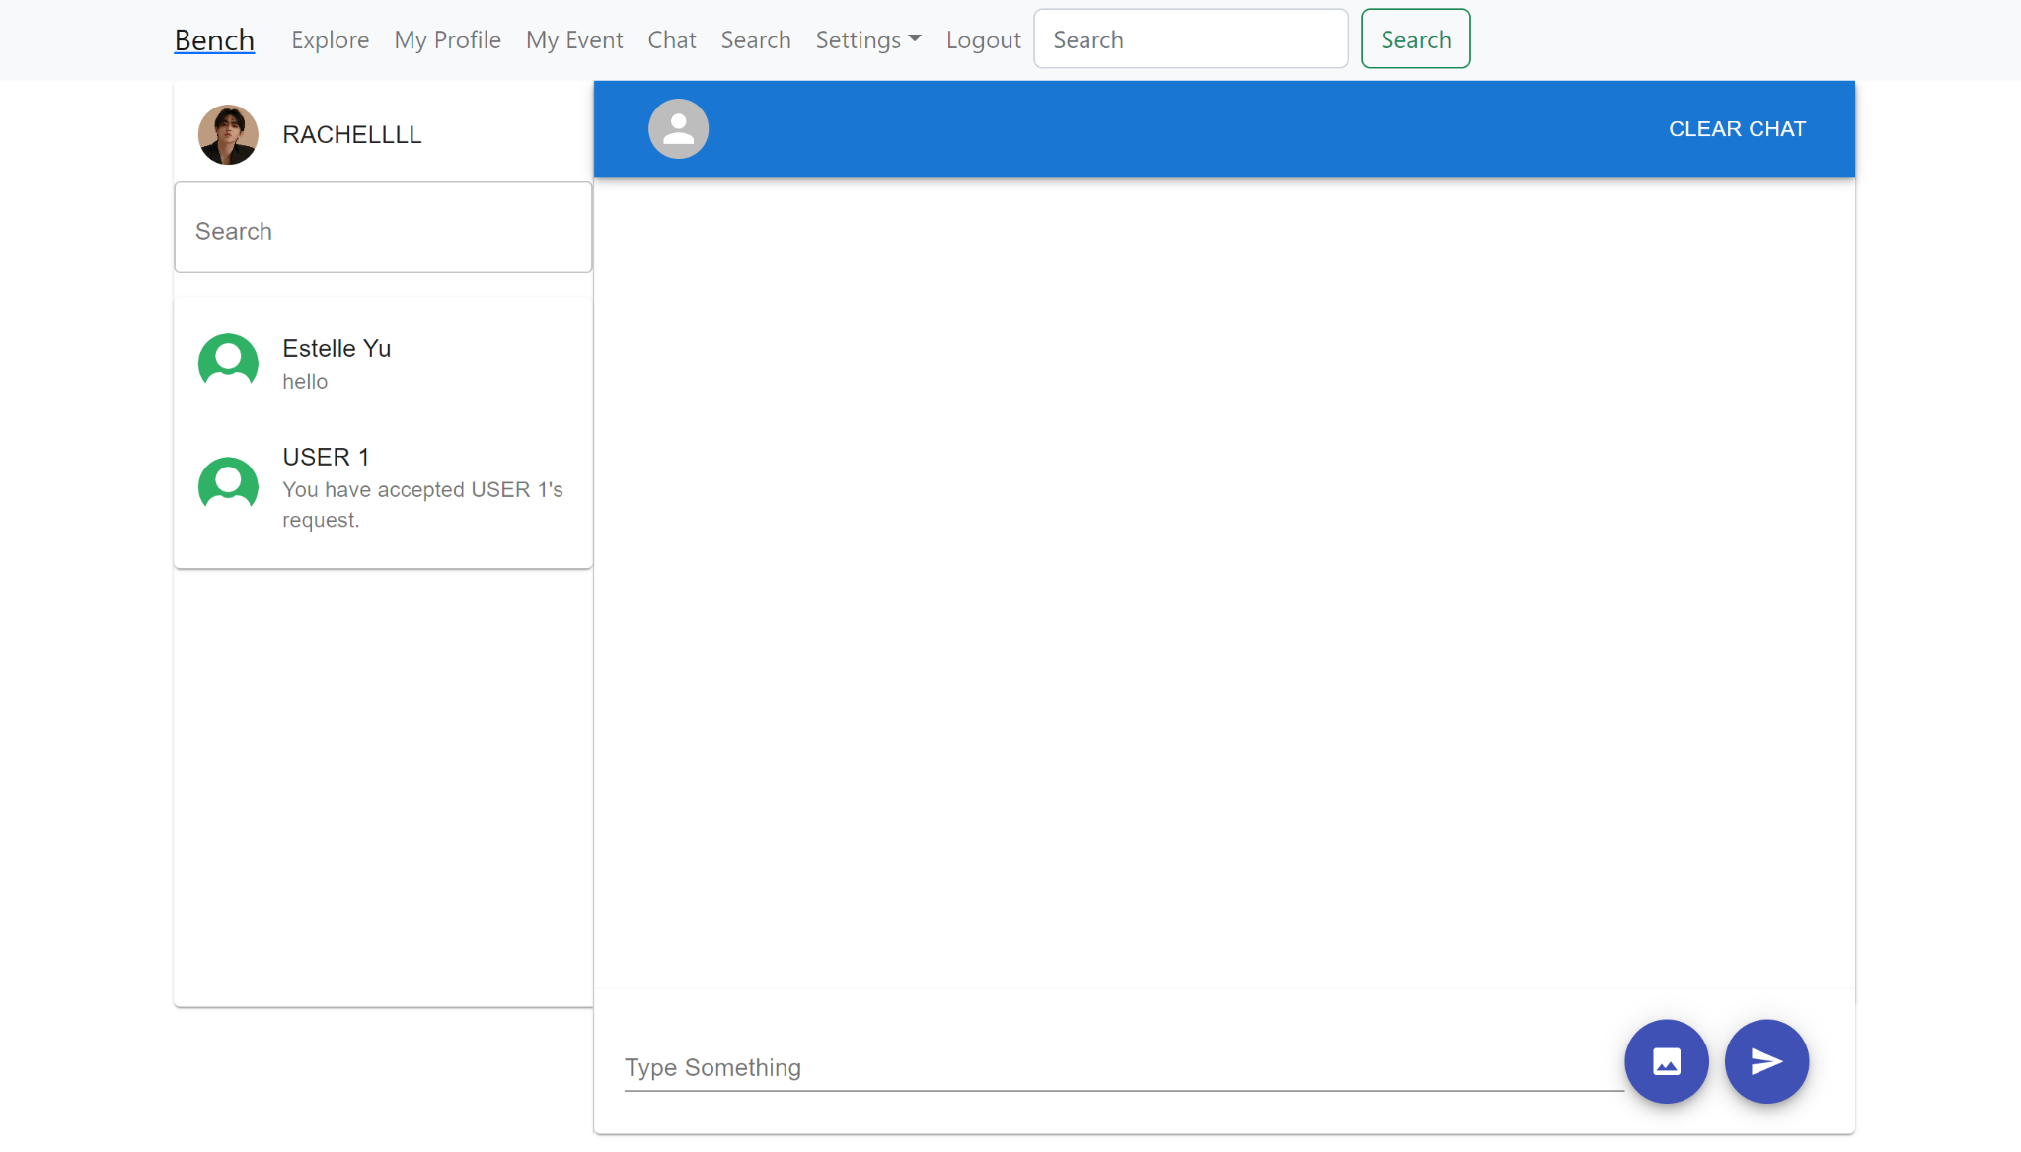

**Test 2**

1. Start the Bench application.
2. Click the button “Login” on the navigation bar.
3. Enter the email “rachel.la2310@gmail.com” into the text field labeled “Email address”.
4. Enter the password “12345678” into the field labeled “Password”.
5. Click the button “Login” below the field.
6. After the screen has loaded, click on the button “Chat” on the navigation bar.
7. There should be a search bar on top of the list of panels for accepted chats on the left side of the Chat page.
8. Enter a username in the search bar.

**Expected Result:** If there exists a chat room between the searched username and the current user, then the search result labeled with the searched username would appear right below the search bar.

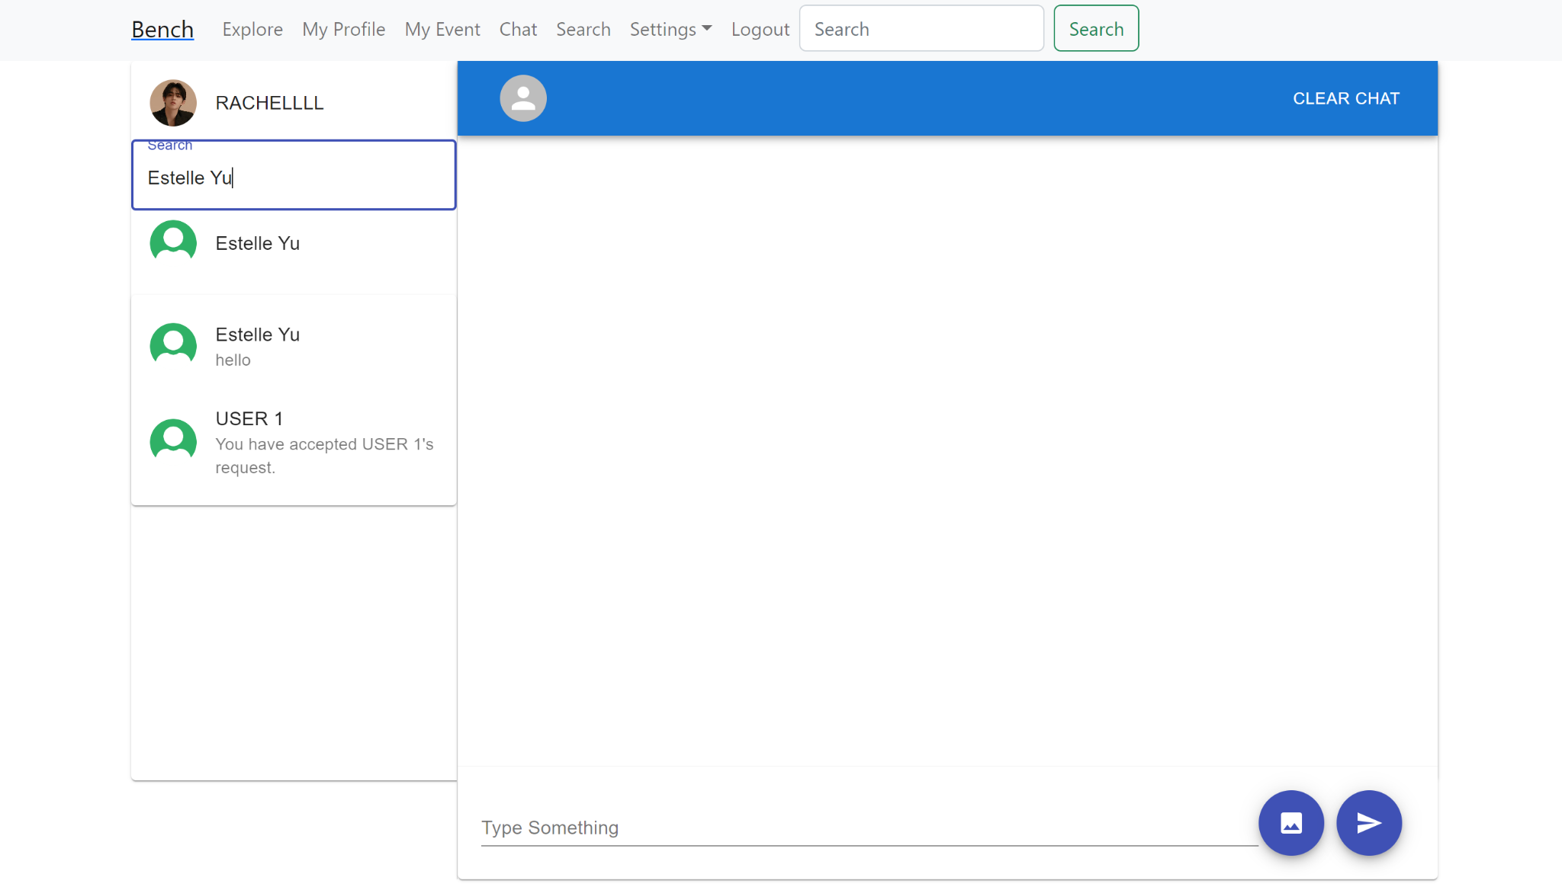

**Test 3**

1. Start the Bench application.
2. Click the button “Login” on the navigation bar.
3. Enter the email “rachel.la2310@gmail.com” into the text field labeled “Email address”.
4. Enter the password “12345678” into the field labeled “Password”.
5. Click the button “Login” below the field.
6. After the screen has loaded, click on the button “Chat” on the navigation bar.
7. There should be a search bar on top of the list of panels for accepted chats on the left side of the Chat page.
8. Enter a username in the search bar.
9. If there exists a chat room between the searched username and the current user, then the search result labeled with the searched username would appear right below the search bar.
10. Click on the search result labeled with the searched username.

**Expected Result:** There should appear the specific chat room between the searched user and the current user with their chat history on the right side of the page.

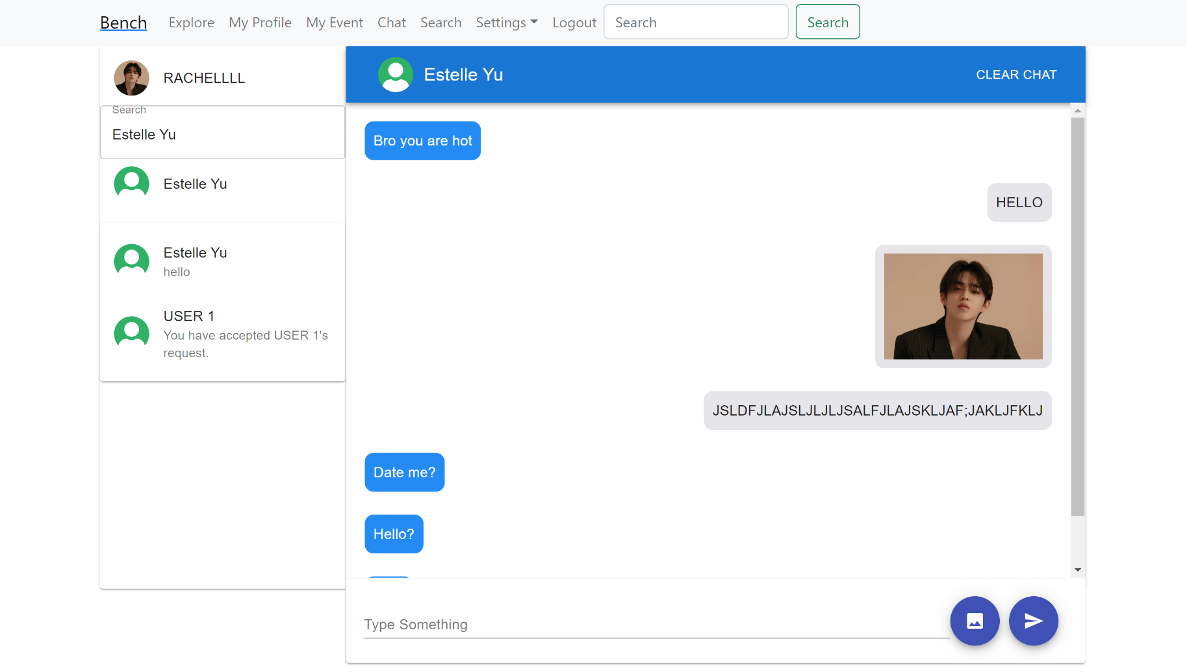

**Test 4**

1. Start the Bench application.
2. Click the button “Login” on the navigation bar.
3. Enter the email “rachel.la2310@gmail.com” into the text field labeled “Email address”.
4. Enter the password “12345678” into the field labeled “Password”.
5. Click the button “Login” below the field.
6. After the screen has loaded, click on the button “Chat” on the navigation bar.
7. There should be a search bar on top of the list of panels for accepted chats on the left side of the Chat page.
8. Enter a username in the search bar of who doesn’t have a chat room with the current user.

**Expected Result:** If there doesn’t exist a chat room between the searched username and the current user, then an error message would appear below the search bar to indicate that no user is found.

